Data analysis Report

GW

KickStarter Chart

Data analysis Conclusions:
Given the provided data the three conclusions we can achieve are the following:

- The sector that is more active in kickstarter is the theatre community. However, Music is the most likely project to be successful as the ratio of success is greater compared to all other sectors.

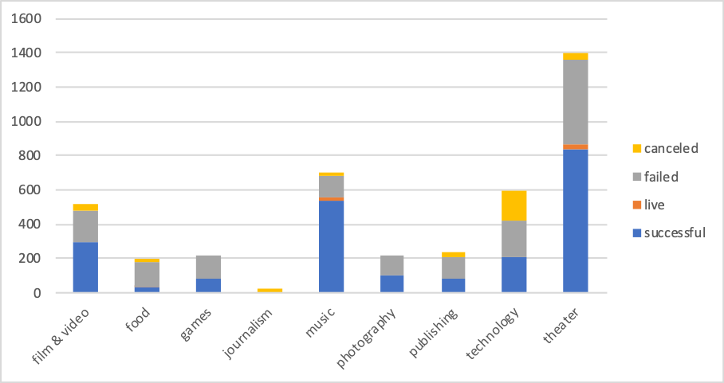

- The sub category of plays is the most active and popular sector in kickstarter community. However, Rock sub category has more chances of success than plays.

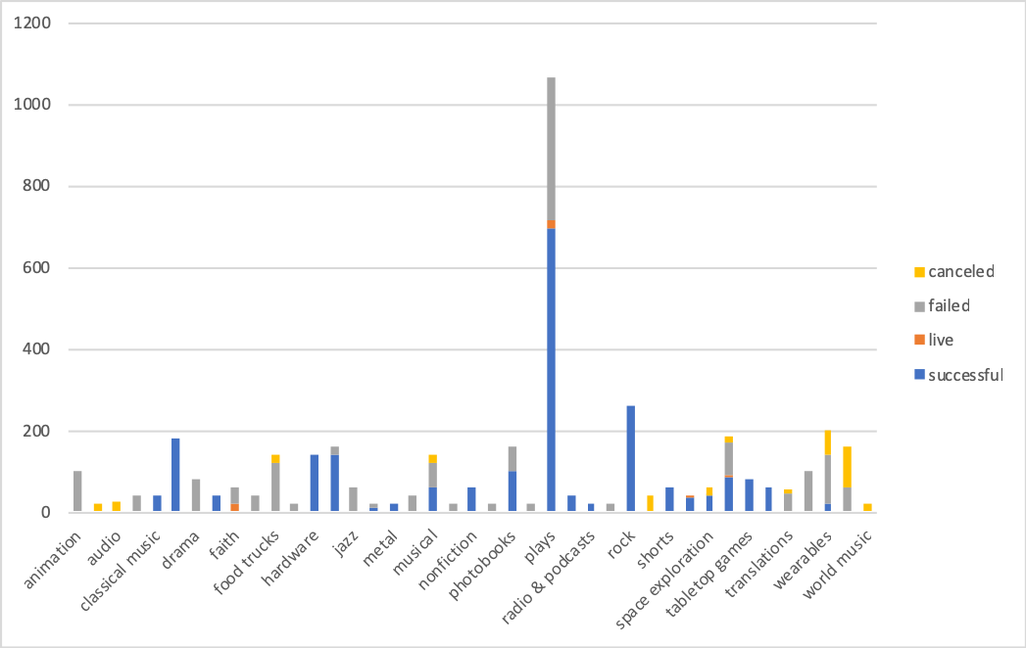

- More projects created at the month of May succeeded. And more projects created in December failed.

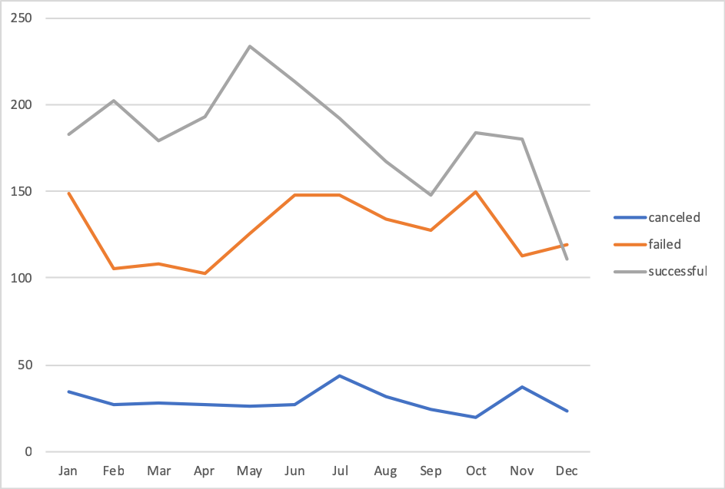

Limitations:
- This database doesn’t contain all the projects in the website, which doesn’t include all other successful or failed projects in different categories.
- The dataset doesn’t give us how much money each backer has pledged and how was the progression of funds throughout the crowdfunding period.
- Also, there is no info about who’s running the projects, their credibility.

Other possible tables/graph:
Count of backers of each category:

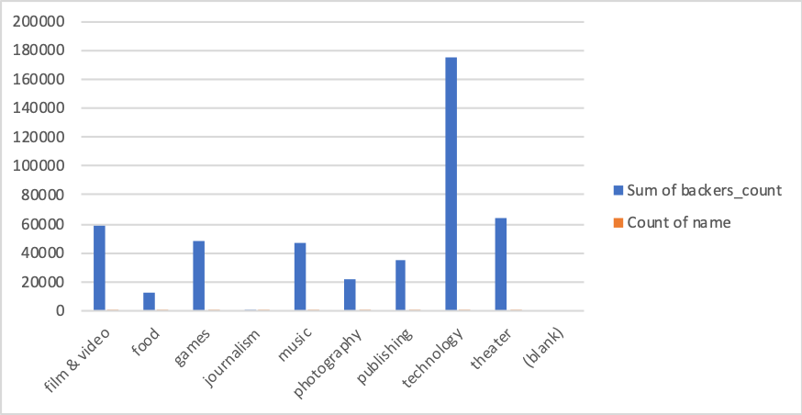

How much money pledged in each category.

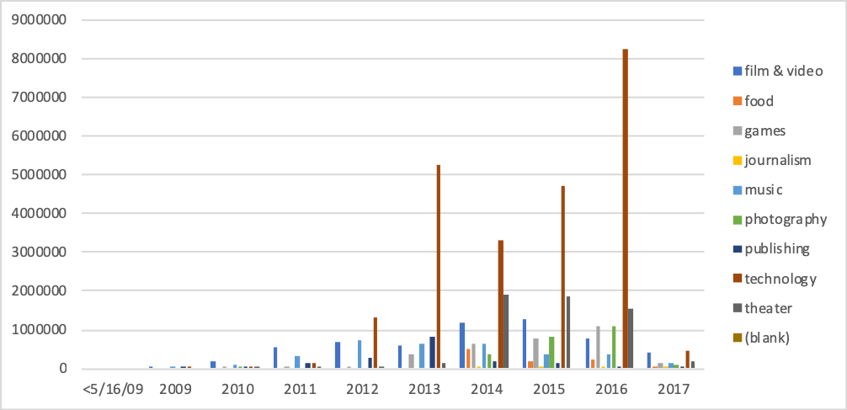

How Many projects created by year in each category:

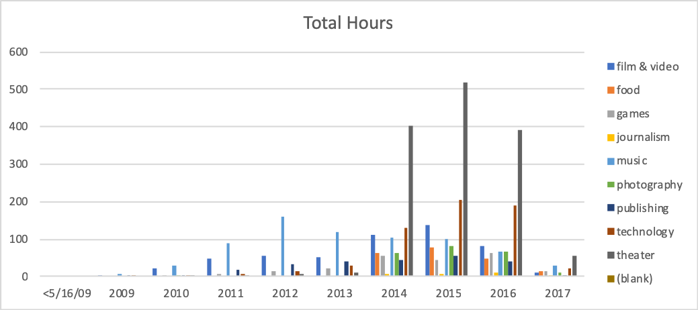

From theses charts we can see that even if Theatre has more projects, Technology has more backers and more funds.

